MEAN stack practice in Window

# Installing nodejs and npm

Assuming that you know how to install nodejs. It is mentioned in another document. At the current, we use nodejs v0.10.34.

Npm also is installed with nodejs. The version of npm is v1.2.*.

We want to use the latest version of npm (v2.1.16) at global scope.

*Remarkable:*

* *Don’t use window command line.*
* *Using nodejs command line by: Start 🡺 All programs 🡺 Nodejs 🡺 Node.js command prompt 🡺 Run as administrator.*

You can use some commands to check current npm information. Sample:

>where npm  
>npm -version // v1.4.28

Installing npm at global scope (need to check npm prefix if you do not install npm at the first time) as:

>npm install npm -g

After that, you can use >where npm to verify that npm exists at two places: one at nodejs folder, one at the Roaming folder for current user. If you use >npm -version command then it will show v2.1.16.

Now, we need to change npm prefix. It is used to point to npmrc. npmrc is used to configure global npm information. Currently, npm prefix points to nodejs as default setting but we don’t use npm at nodejs.

You can use command line to check this prefix as:

>npm prefix -g // It will show nodejs folder as default setting

You change prefix setting by:

>npm config set prefix C:\Users\pxcong\AppData\Roaming\npm

And checking it again. Note that when you uninstall npm and nodejs then prefix setting will not be changed. So, you need to check it when you install/uninstall any packages.

Next, we uninstall npm instance at nodejs folder as:

>npm uninstall npm -g

The result is we only have one npm instance at Roaming folder.

# Installing WebStorm

You can download WebStorm at: <https://www.jetbrains.com/webstorm/>

Only download and install it. Recommending that you use it to develop MEAN project.

# Setting up Demo project environment

I use MEANDemo for my demo project.

## Setting up npm init

Going to MEANDemo folder and running command:

MEANDemo>npm init

And input something like this:

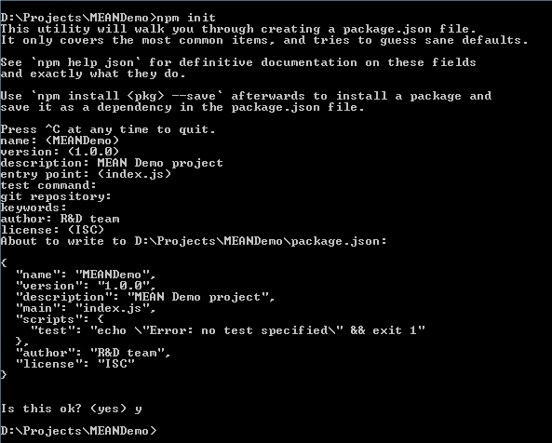

It will create new package.json file as:

{  
 "name": "MEANDemo",  
 "version": "1.0.0",  
 "description": "MEAN Demo project",  
 "main": "index.js",  
 "scripts": {  
 "test": "echo \"Error: no test specified\" && exit 1"  
 },  
 "author": "R&D team",  
 "license": "ISC"  
}

You can modify it if you want.

## Pre installing/uninstalling npm packages

You can go to <https://docs.npmjs.com/cli/install> for more details.

npm has two modes:

* Global mode: appends -g OR --global to install/uninstall command. Using this mode, npm will install/uninstall at Roaming folder for current user.
* Normal mode: does not append anything. Using this mode, npm will install/uninstall at current folder.

Install/Uninstall options:

* --save: Package will appear/disappear in your dependencies.
* --save-dev: Package will appear/disappear in your devDependencies.
* --save-optional: Package will appear/disappear in your optionalDependencies.

🡺 It modifies the content of package.json file.

Sample:

"dependencies": {  
 "yo": "^1.3.3"  
},  
"devDependencies": {  
 "jade": "^1.8.2"  
},  
"optionalDependencies": {  
 "morgan": "^1.5.0"  
}

Dependencies item contains all packages that need to run program. DevDependencies item contains all packages that need to develop or test.

Nodejs v0.10.26 or newer does not use tilde (~), just use caret (^). Sample:

~1.3.3 matches with 1.3.x  
^1.3.3 matches with 1.x.x

You can specify the newest version or specific version of any packages as sample:

>npm install bower // install newest version  
>npm install [bower@1.3.12](mailto:bower@1.3.12) // install version 1.3.12

## Installing and configuring bower

You can read <http://bower.io/> for more information. You also read <http://ng-learn.org/2013/11/Bower-vs-npm/> for know when we use npm or bower.

When you want to use bower for other projects then you can install it with global mode. And for each project, we will create new bower configuration. Otherwise, you install it into your project.

To install it with global mode, we do as:

>npm install bower -g

And checking version as:

>bower -v // v1.3.12

You need to tell to bower where to install packages into your project. You create .bowerrc file manually same as:

{  
 "directory": "public/vendor"  
}

public is folder to contain all things to run website.

Next, we will create bower configuration file by command:

>bower init

And input some information as:

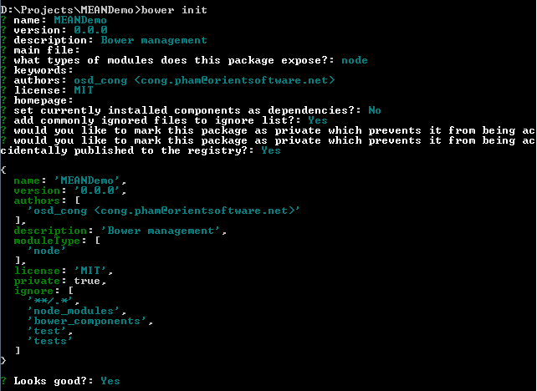

It creates bower.json file and you can modify it later.

## Installing packages

We use npm to install some packages that are used for server side as:

>npm install express --save // JS server  
>npm install jade --save // jade script  
>npm install morgan --save // logging  
>npm install stylus --save // stylus css  
>npm install body-parser --save

And we use bower to install packages that are used for frontend as:

>bower install angular --save  
>bower install angular-resource --save  
>bower install angular-route --save  
>bower install jquery --save  
>bower install bootstrap --save

You can check package.json and bower.json to verify the result. It’s ready to code your project now.